Q5 TASK: Write a description suggested by this picture
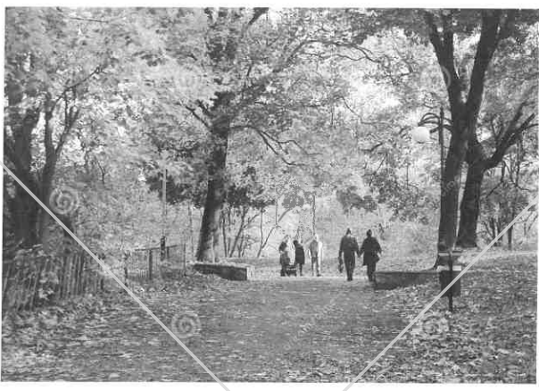
Model Response:
A gentle breeze rustled the last few leaves left on the trees. Bare branches stretched across the dull autumn sky; the sun struggled to shine through the dark clouds. The floor was a golden pathway from the debris of fallen leaves. A cacophony of burnt yellows and deep ambers mingled together in the late afternoon.
People waded through the multitude of leaves as they crossed the park. Children ran, kicking up explosions of reds, yellows and oranges. Laughter and giggles hung in the air as families enjoyed their day out. Wrapped tightly in scarves, hats and gloves, the chilly air could only bite at their exposed noses. Rose red cheeks adorned each smiling face as they were creating new and exciting memories to look back on.
On a bench, just to the side of the park, an old lady sat deep in though. Looking at the families around her, she recalled a time when her husband would swing their daughter around with ease. He would carry her through the park on his shoulders like she weighed nothing.
“Faster daddy…faster!” a child demanded, and the old lady’s dreams shattered. The lady’s eyes swam with ghosts of the past. A smile of longing played across her face…her memories had been snatched form her abruptly, unfairly, by the imperious toddler.
Across the horizon, the sun began to die, a lingering embrace of faint warmth chased away by the coming night. The clouds drew together in conspiracy, completely blotting out the sun. A light drizzle began to fall over the park. Leaves clumped together, squelching under feet as the wandering families began to hurry home. In the distance, a flurry of colour could be seen: gold, maroon, bronze and auburn. Winds began to whip wildly across the last few stragglers, hurrying them homeward.
All too soon, they thought, it would be winter.

