AQA Sample Paper: GCSE English Language

Paper 2: Writers’ viewpoints and perspectives

Time allowed: 1 hour 45 minutes

- The marks for questions are shown in brackets.
- The maximum mark for this paper is 80.
- There are 40 marks for Section A and 40 marks for Section B.
- You are reminded of the need for good English and clear presentation in your answers.
- You will be assessed on the quality of your reading in Section A.
- You will be assessed on the quality of your writing in Section B.
You are advised to spend about 15 minutes reading through the Source and all five questions you have to answer. You should make sure you leave sufficient time to check your answers.

Source A: 21st century nonfiction
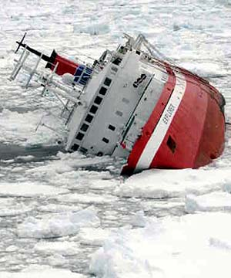
Taken from Boating Safety and Safe Boating Blog
How to Survive a Sinking Ship
You've obtained your boat license and are now ready to venture out for some sea-bound fun. But would you know what to do if you were on a sinking ship? The following article will outline the steps you should take if ever you find yourself aboard a sinking ship. Fortunately, the odds of surviving a sinking ship are very high. The most important thing to do is stay calm.
Be prepared
Anyone who's had experience as a scout will know these 2 words: "be prepared". The meaning behind this famous saying is closely tied to another famous saying "knowing is half the battle". Those two bits of advice could very well save your life on a sinking ship.
Before even stepping aboard, prepare an evacuation bag complete with the tools you'd need to survive on a raft or an island.
Your survival kit should include:
- Compass
- Flashlight
- Waterproof matches
- Knife
- Sunscreen lotion
- Fresh water
- Mirror for signalling
- Flares
- First aid kit
- Some food rations
Learn Where Everything Is
Make sure to explore the ship and become familiar with all the emergency exits and evacuation maps. Find the closest lifeboat to your cabin, and be sure to know where all the life jackets are. When it comes to ocean survival, floating is everything. You may have been able to tread water for hours back in the old swimming pool, but the ocean is much, much colder and rough. You'll already be fatigued and in a relative state of shock, and the ocean is filled with various forms of dangly leg-eaters.
Calm Down!
So there you are, relaxing by the pool when suddenly the loud horn lets out 7 short bursts followed by one long one. This is not the boat playing battleship via Morse code with another distant ship, this is in fact the signal to abandon ship.
Screaming and running is the quickest way to get yourself killed. You're not thinking clearly, making terrible decisions, expending valuable energy and rushing into the madness of the mob. One trip and you could get trampled. Let the frenzying folk do their thing, and practice a little something called square breathing.
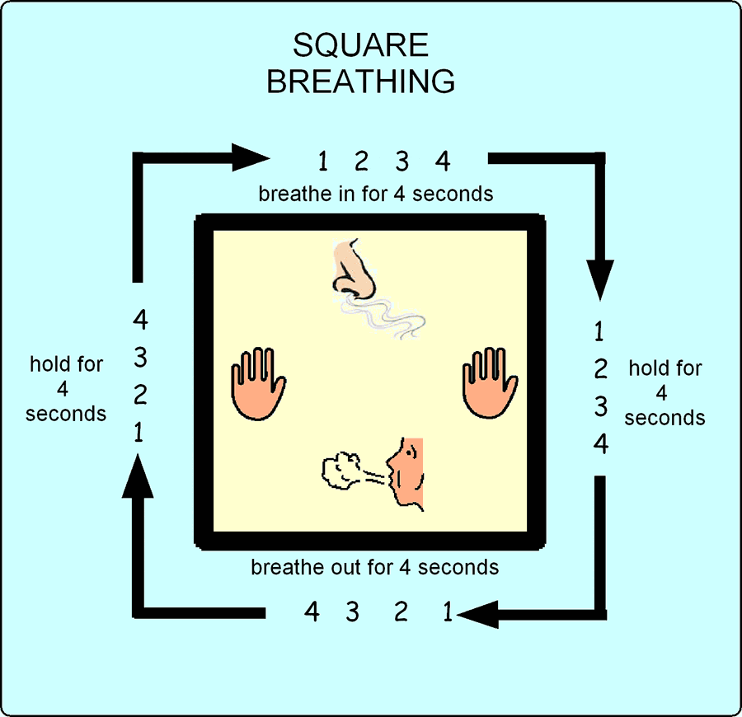
Square Breathing:
- Inhale deeply for 4 seconds
- Hold your lungs full for 4 seconds
- Exhale for 4 seconds
- Hold your longs empty for 4 seconds
Do this 3-4 times and your nerves will settle, your heart rate will slow, and you will find it much easier to focus on survival. This simple technique is used in the military to lower the heart rates of snipers.
Statistically speaking, in an emergency scenario 70% of people will panic, 15% are going to make irrational decisions, and only the remaining 15% will be thinking clearly. Remaining calm already places you above 85% of the rest of the ship.
Follow the rats!
If the hull is breached and the ship begins to take on water, the lowest parts of the ship are generally filled first. This is also where much of a ship's vermin dwell. Rats have been known to be the first to abandon a sinking ship, which seems like intelligence at first until they plunge into the ocean and drown anyhow. They do however, set the right example of where to go as the ship is filling up.
Getting to the deck as fast as possible is extremely important. It would seem fairly obvious to avoid heading deeper and more towards the center of the ship as it sinks, but when panic sets in it's easier to lose orientation and to get lost. Similarly to a burning building situation, avoid using the elevators; it would be terrible to get stuck in one as the boat goes under. If you have time, make sure to grab your evacuation bag!
A stable ship is a sinking ship
A good thing to know if you're on the deck of your own boat, if the boat seems to be rolling less than it should, it could be filling up with water. The weight of the water is preventing your boat from rolling with the waves, time to abandon ship!
Calling for Help
If you're on a big cruise ship, you are clearly not responsible for calling for help. If you're on your own boat however, it's important to not only have a radio, but to know how to use it. Your radio should always be on and tuned to marine VHF radio channel Six-Teen (16) or Frequency 161.400 or 156.800 MHz; marine MF/SSB on 2182 kHz. The coastguard and other ocean rescue authorities are constantly monitoring these channels and will be able to dispatch help in an emergency. Most modern radios are equipped with a Digital Select Calling (DCS) button, which will send your GPS coordinates along with a Mayday beacon to the coastguard once pressed.
Life boats
Without pushing or shoving, find a lifejacket, put it on before helping anyone else, and get yourself on a lifeboat in an orderly fashion. Your own morals will dictate whether you let women and children on the boats first, just know that the longer you stay aboard, the lower your chances of survival. And if you end up in the water as opposed to aboard a life raft, your odds for survival drop by as much as 70%. The water surrounding the Titanic when it sank was 28 degrees, giving swimmers about 15-30 minutes before their hearts stopped.
"The majority of the survivors of the Titanic disaster "were women, children and people with young children," Thomas H. Maugh II wrote for the Los Angeles Times, compared to the Lusitania, where they were primarily "young men and women who responded immediately to their powerful survival instincts," according to the Associated Press."
Source: Sinking Ship Escape Etiquette
Tips to follow once on the lifeboat:
- Continue to remain calm
- Protect your skin from the sun
- Drink your fresh water sparingly
- Whenever it rains use whatever you can to capture the water. Dehydration occurs quickly on the open seas.
- The vastness of the ocean and the apparent "hopelessness" of the situation can make people freak out, so try to keep people's brains occupied with conversation, singing, or games.
All you can do at this point is let the raft drift to shore, using your flares sparingly to attract the attention of other boats or aircraft.

Source B: 19th century literary nonfiction

Extract from a booklet containing an eye-witness account of a shipwreck
that occurred in Seaford in 1809.

One of the two men that were preserved of this vessel, had his nose cut asunder by the sudden fall of some timber upon him before he quit the ship, but his wound, though painful, turned out neither malignant nor dangerous.
All of the distressed crews that could, by the most resolute efforts, be saved from the various vessels, were saved before ten o'clock in the morning, one only excepted, the preservation of whom is deserving of particular mention, and the following are the circumstances of it:-
The piteous spectacle of the wrecks was within a very short distance of Blatchington; and the Commanding Officer of the military there stationed, Captain Brown, and the greater part of the subordinates of the 81st infantry, as well as the Officers generally of that regiment, took very active and humane parts on the luckless situation.
It so occurred, that Mr. Derenzy, a Lieutenant in the 81st, after various successful efforts in rescuing his fellow-men from the brine of death, discovered a poor mariner in the last agonies of exhaustion, sometimes beneath and sometimes above the surface of the billows*, feebly buffeting the waves, with the dying hope of being yet enabled of reaching the shore.
The soul of the truly courageous but tender-hearted veteran, was sensibly touched by the distressing picture of human woe that was now again exhibited before him, and he carefully watched every movement of the sufferer under the gratifying persuasion that the moment would arrive when he, by plunging in the water, should be able to afford him effectual relief.
The drowning man, however, appeared to have expended the last effort he could command soon after Mr. Derenzy had discovered him, and, at length, as resignant to the will of the all-good and all-powerful spirit of the universe, his eyes were raised on high, and the next moment he sunk as in the icy embrace of death.
The feelings of Mr. Derenzy were now wrought up to the highest pitch of agony -"I'll save the poor fellow," he exclaimed, "or perish in the attempt," and instantly plunged into the foaming surges, and was for some time lost to observation.
This brave and noble character, however, was at length, grasping firmly part of the habilements* of the object he had sought with one hand, while, with the other, he attempted to make good his return to the land. At this critical moment, a heavy fragment of the wreck struck Mr. Derenzy on the temple; the blow was forcible, and deprived him of his senses; he could no longer strive to stem the current and regain the land; but still held the poor sailor in his grasp, until lost, as it were, in the torpor* of death, both sank together.
*Glossary
billows = large sea waves
habilements = clothing
torpor = a state of physical or mental inactivity; tiredness

Section A: Reading
Answer all questions in this section.
You are advised to spend about 45 minutes on this section.

Q1. Read again the first part of Source A from lines 1 to 33.

Choose four statements below which are true. [4 marks]

- You are unlikely to survive being on a sinking ship.
- Staying calm is very important if you are on a sinking ship.
- Passengers on boat trips are always provided with a survival kit.
- Your survival kit should include something to eat.
- It is important to know where your closest lifeboat is.
- You should carry a lifejacket at all times when on board.
- It is easier to tread water in the sea than in a swimming pool because of the salt water.
- If you hear the horn eight times, this is the signal to abandon ship.

Q2. You need to refer to Source A and Source B for this question.

Use details from both sources. Write a summary of the differences in the purposes of the two texts.
[8 marks]

Q3. You now need to refer to Source B, lines 15-31 only.

How does the writer use language to show Mr Derenzy’s bravery?
[12 marks]

Q4. You need to refer to Source A and Source B for this question.

Compare how the two writers convey different attitudes towards being on a sinking ship.

In your answer, you could:
- compare their different attitudes
- compare the methods they use to convey their attitudes
- support your ideas with references to both texts
[16 marks]

Section B: Writing
You are advised to spend about 45 minutes on this section.
Write in full sentences.
You are reminded of the need to plan your answer.
You should leave enough time to check your work at the end.

Q5. ‘Survival skills should be a part of the school curriculum.’

Write an article for an e-magazine aimed at people your age, giving your thoughts in response to this statement.

(24 marks for content and organisation
16 marks for technical accuracy)
[40 marks]

